We will use:
- 🔹 Frontend: React JS
- 🔹 Backend: Node.js + Express
- 🔹 Database: MongoDB
- 🔹 Image Upload: Multer
- 🔹 Authentication: JWT
STEP 1: Project Setup

1 Create Project Folder

STEP 2: Backend Setup

1️⃣ Create Backend Folder
mkdir backend
cd backend
npm init -y

2️⃣ Install Required Packages
npm install express mongoose cors dotenv bcryptjs jsonwebtoken multer

3️⃣ Create Folder Structure
backend/
│── models/
│── routes/
│── controllers/
│── middleware/
│── uploads/
│── server.js

🚀 STEP 3: Create Server

📌 server.js
const express = require("express");
const mongoose = require("mongoose");
const cors = require("cors");
require("dotenv").config();

const app = express();

app.use(cors());
app.use(express.json());
app.use("/uploads", express.static("uploads"));

mongoose.connect("mongodb://127.0.0.1:27017/socialmedia")
.then(() => console.log("MongoDB Connected"))
.catch(err => console.log(err));

app.use("/api/users", require("./routes/userRoutes"));
app.use("/api/posts", require("./routes/postRoutes"));

app.listen(5000, () => console.log("Server running on port 5000"));
Run backend:
node server.js

🚀 STEP 4: Create User Model

📌 models/User.js
const mongoose = require("mongoose");

const userSchema = new mongoose.Schema({
username: String,
email: String,
password: String,
followers: [{ type: mongoose.Schema.Types.ObjectId, ref: "User" }],
following: [{ type: mongoose.Schema.Types.ObjectId, ref: "User" }]
});

module.exports = mongoose.model("User", userSchema);

🚀 STEP 5: Create Post Model

📌 models/Post.js
const mongoose = require("mongoose");

const postSchema = new mongoose.Schema({
user: { type: mongoose.Schema.Types.ObjectId, ref: "User" },
caption: String,
image: String,
likes: [{ type: mongoose.Schema.Types.ObjectId, ref: "User" }],
comments: [{
user: { type: mongoose.Schema.Types.ObjectId, ref: "User" },
text: String
}]
}, { timestamps: true });

module.exports = mongoose.model("Post", postSchema);

🚀 STEP 6: Authentication (Register + Login)

📌 routes/userRoutes.js
const router = require("express").Router();
const User = require("../models/User");
const bcrypt = require("bcryptjs");
const jwt = require("jsonwebtoken");

// Register
router.post("/register", async (req, res) => {
const hashedPassword = await bcrypt.hash(req.body.password, 10);

const user = new User({
username: req.body.username,
email: req.body.email,
password: hashedPassword
});

await user.save();
res.json({ message: "User Registered" });
});

// Login
router.post("/login", async (req, res) => {
const user = await User.findOne({ email: req.body.email });
if (!user) return res.status(400).json("User not found");

const validPass = await bcrypt.compare(req.body.password, user.password);
if (!validPass) return res.status(400).json("Invalid Password");

const token = jwt.sign({ id: user._id }, "secretkey");
res.json({ token });
});

module.exports = router;

🚀 STEP 7: Post Routes (Create, Like, Comment)

📌 routes/postRoutes.js
const router = require("express").Router();
const Post = require("../models/Post");
const multer = require("multer");

// Image Upload
const storage = multer.diskStorage({
destination: "uploads/",
filename: (req, file, cb) => {
cb(null, Date.now() + "-" + file.originalname);
}
});
const upload = multer({ storage });

// Create Post
router.post("/create", upload.single("image"), async (req, res) => {
const post = new Post({
user: req.body.userId,
caption: req.body.caption,
image: req.file.filename
});

await post.save();
res.json(post);
});

// Like Post
router.put("/like/:id", async (req, res) => {
const post = await Post.findById(req.params.id);
post.likes.push(req.body.userId);
await post.save();
res.json("Post Liked");
});

// Comment
router.post("/comment/:id", async (req, res) => {
const post = await Post.findById(req.params.id);
post.comments.push({
user: req.body.userId,
text: req.body.text
});

await post.save();
res.json("Comment Added");
});

module.exports = router;

🚀 STEP 8: Frontend Setup (React)
Go back to root folder:
npx create-react-app frontend
cd frontend
npm install axios react-router-dom

🚀 STEP 9: Basic Pages
Create:
src/
│── pages/
│ ├── Login.js
│ ├── Register.js
│ ├── Home.js
│── components/
│ ├── PostCard.js
│ ├── Navbar.js

🚀 STEP 10: Example Post Creation

📌 Create Post Form
import axios from "axios";
import { useState } from "react";

function CreatePost() {
const [caption, setCaption] = useState("");
const [image, setImage] = useState(null);

const handleSubmit = async (e) => {
e.preventDefault();
const formData = new FormData();
formData.append("caption", caption);
formData.append("image", image);
formData.append("userId", localStorage.getItem("userId"));

await axios.post("http://localhost:5000/api/posts/create", formData);
alert("Post Created");
};

return (
<form onSubmit={handleSubmit}>
<input type="text" onChange={(e)=>setCaption(e.target.value)} />
<input type="file" onChange={(e)=>setImage(e.target.files[0])} />
<button type="submit">Post</button>
</form>
);
}

export default CreatePost;

OUTPUT:
REGISTER PAGE:
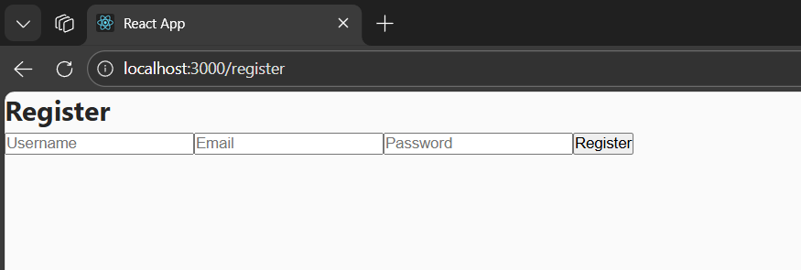

lOGIN PAGE
